# Jenkins - Managing Plugins

Jenkins provides a variety of plugins for a different task. To see the list of all available plugins in Jenkins, open the following link: [https://plugins.jenkins.io/](https://plugins.jenkins.io/" \t "https://www.javatpoint.com/_blank)

We have already seen many plugins in our previous sections. Let's see some maintenance tasks related to plugins.

## Installing Plugins:

**Step 1:** To install a plugin, go to the Jenkins Dashboard and click on **Manage Jenkins**.

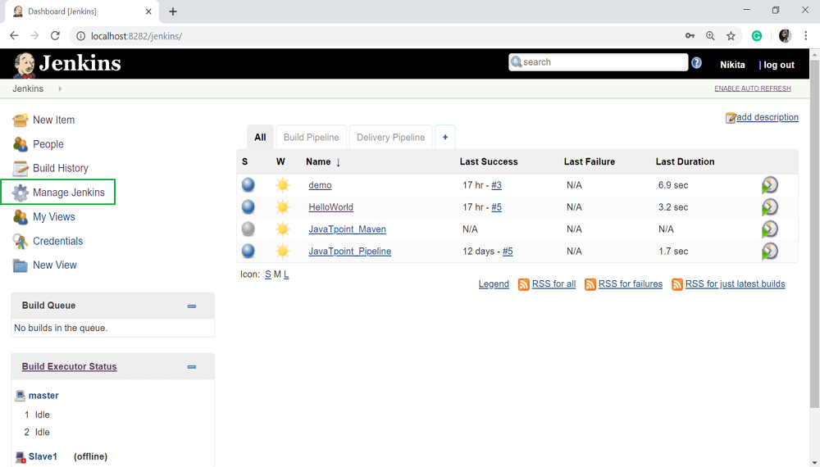

**Step 2:** Scroll down and select **Manage Plugins**.

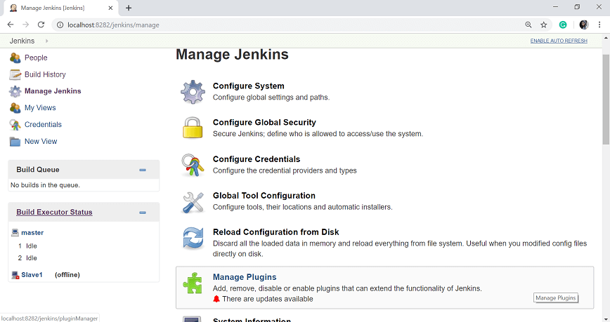

**Step 3:** Go to the **Available** tab and in the filter option, search for the plugins which you want to install.

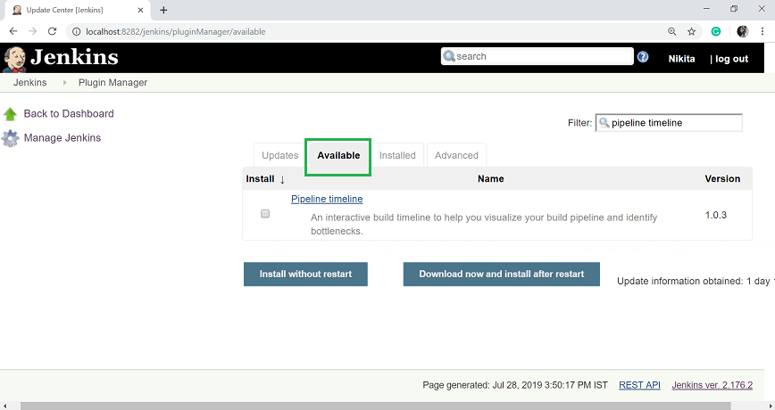

**Step 4:** Select that plugins and click on **Install without restart** button. You can also **choose Download now and install after restart** button.

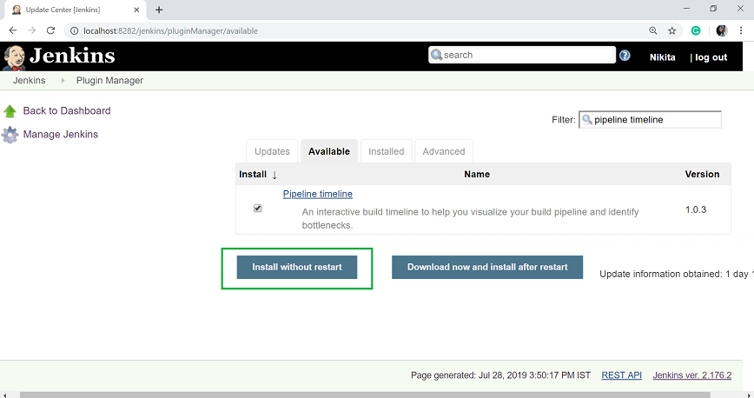

Once the installation has been completed successfully, click on **Go back to the top page** link.

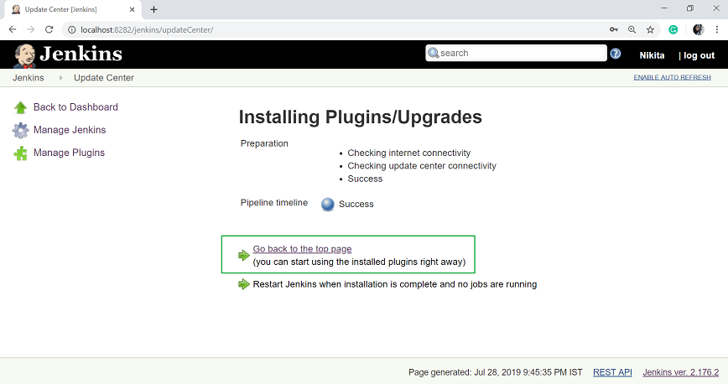

## Uninstalling Plugins

**Step 1:** To uninstall a plugin in Jenkins, go to the **Manage Jenkins**.

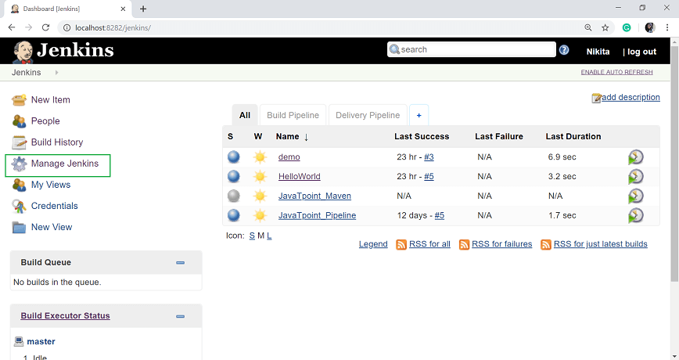

**Step 2:** Select **Manage Plugins**.

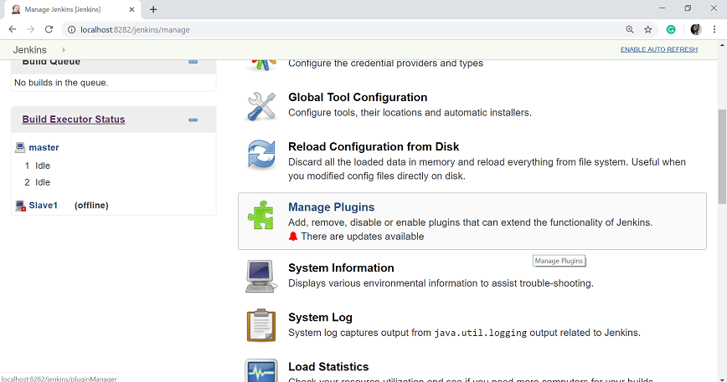

**Step 3:** Click on the **Installed** tab. And select the pipeline which you want to uninstall and click on **Uninstall** button.

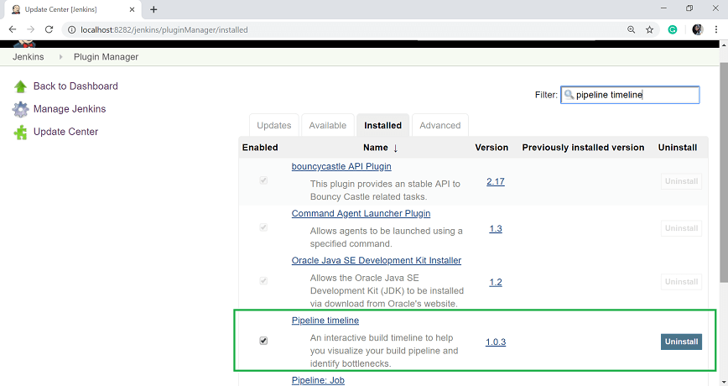

**Step 4:** Click on **Yes** button.

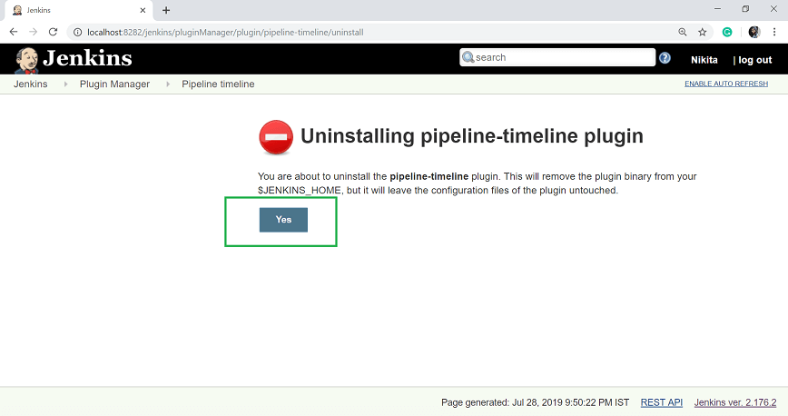

Your selected plugin will remove successfully.

## Installing the plugin manually

Sometimes it may be necessary to install an older version of a plugin, in such a case, you install the plugin manually.

**Step 1:** For this, first, you have to download the plugin from the relevant plugin page on the Jenkins website. Then go to the Jenkins dashboard and select **Manage Jenkins**.

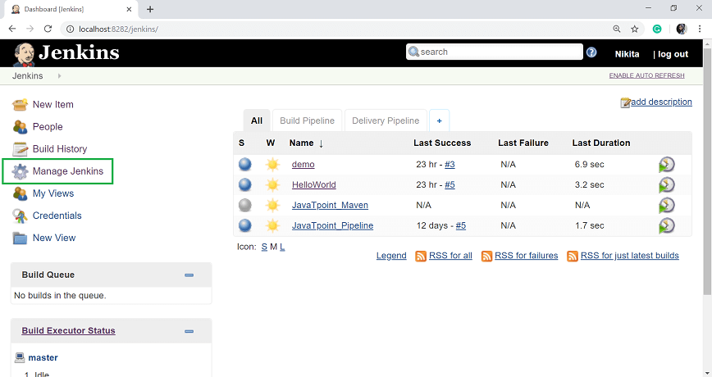

**Step 2:** Select **Manage Plugins**.



**Step 3:** Click on **Advanced** tab and on the upload plugin section browse the downloaded plugin's location.

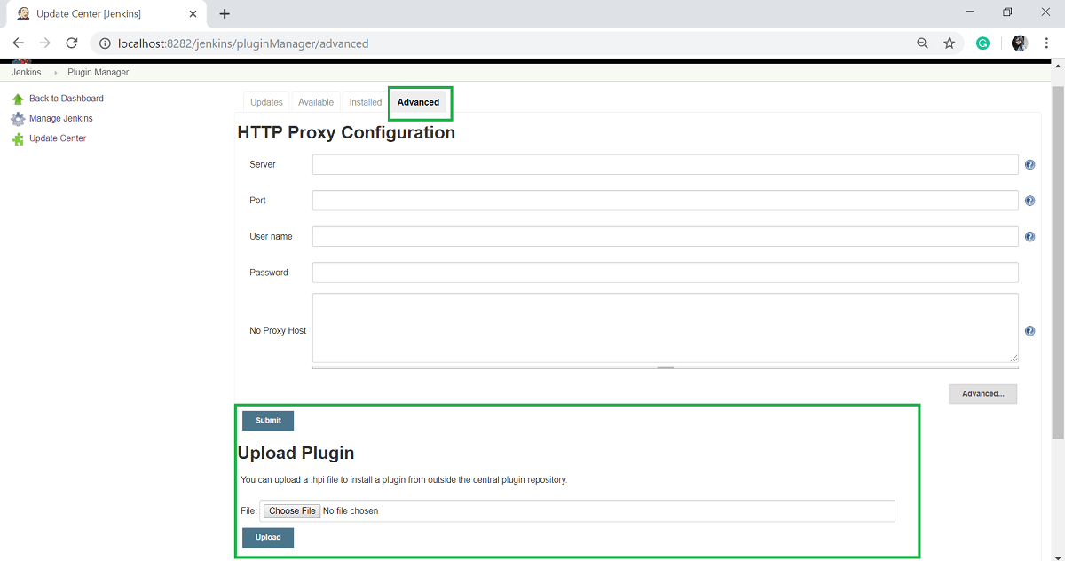

**Step 4:** Then click on the **Upload** button.